 | Full (Ref)  N=7,019 | Marginal  N=1,136 | Low  N=1,218 | Very Low  N=721 | Overall  (N=10,094)
 | N (%) | N (%) | N (%) | N (%) | N (%)
Sex
Male | 3509 (50) | 533 (46.9) | 569 (51.5) | 569 (46.7) | 4,954 (49.1)
Female | 3,510 (50.0) | 603 (53.1) | 649 (53.3) | 378 (52.4) | 5,140 (50.9)
Age (years) | 49 (19) | 42 (18) | 42 (17) | 42 (16) | 47 (19)
Race/Ethnicity
NH White | 3,412 (48.6) | 345 (30.4) | 318 (26.1) | 250 (34.7) | 4,325 (42.8)
NH Black | 1,441 (20.5) | 297 (26.1) | 331 (27.2) | 194 (26.9) | 2,263 (22.4)
Mexican-American | 868 (12.4) | 267 (23.5) | 294 (24.1) | 139 (19.3) | 1,568 (15.5)
Other Hispanic | 520 (7.4) | 126 (11.1) | 165 (13.5) | 95 (13.2) | 906 (9.0)
Other, incl. Multi-Racial | 778 (11.1) | 101 (8.9) | 110 (9.0) | 43 (6.0) | 1,032 (10.3)
Highest Educational Attainment
Less than 9th Grade | 1,382 (19.7) | 396 (34.9) | 504 (41.4) | 284 (39.4) | 2,566 (25.4)
High School Graduate or Equivalent | 1,730 (24.6) | 320 (28.2) | 327 (26.8) | 197 (27.3) | 2,574 (25.5)
Some College | 1,939 (27.6) | 313 (27.6) | 303 (24.9) | 210 (29.1) | 2,756 (27.4)
College or Above | 1,968 (28.0) | 107 (9.4) | 84 (6.9) | 30 (4.2) | 2,189 (21.7)
Poverty Income Ratio
Low Poverty | 993 (14.1%) | 397 (34.9%) | 528 (43.3%) | 375 (52.0%) | 2,293 (22.7%)
Near Poverty | 1,560 (22.2%) | 405 (35.7%) | 458 (37.6%) | 262 (36.3%) | 2,685 (26.6%)
Middle Income | 1,085 (15.5%) | 178 (15.7%) | 127 (10.4%) | 53 (7.4%) | 1,443 (14.3%)
Upper-Middle Income | 1,679 (23.9%) | 124 (10.9%) | 91 (7.5%) | 27 (3.7%) | 1,921 (19.0%)
High Income | 1,702 (24.2%) | 32 (2.8%) | 14 (1.1%) | 4 (0.6%) | 1,752 (17.4%)
Cycle Year
2005–2006 | 1,179 (16.8) | 154 (13.6) | 148 (12.2) | 70 (9.7) | 1,551 (15.4)
2007–2008 | 1,313 (18.7) | 175 (15.4) | 168 (13.8) | 93 (12.9) | 1,749 (17.3)
2009–2010 | 1,246 (17.8) | 197 (17.3) | 234 (19.2) | 148 (20.5) | 1,825 (18.1)
2011–2012 | 1,109 (15.8) | 195 (17.2) | 192 (15.8) | 127 (17.6) | 1,623 (16.1)
2013–2014 | 1,203 (17.1) | 199 (17.5) | 218 (17.9) | 138 (19.1) | 1,758 (17.4)
2015–2016 | 969 (13.8) | 216 (19.0) | 258 (21.2) | 145 (20.1) | 1,588 (15.7)

Table 1: Unweighted Demographic Characteristics of the Analytic Study Population
- Unweighted descriptive statistics count (frequency) and proportion (percentage) per food security category reported.

Study Population Descriptive Statistics
10,094 participants were included in the final analytic study (Table 1). 50.9% of which self-reported as female. Individuals with high food security were older on average (47 years) compared to the remaining food security categories (42 years). Non-Hispanic White adults represented majority of the population (42.8%), followed by Non-Hispanic Black (22.4%) and Mexican American (15.5%). The distribution across food security categories differed by race/ethnicity. Non-Hispanic Black and Mexican American adult participants represented higher proportions of the Low (27.2% and 24.1%) and Very Low (26.9% and 19/3%) food security groups relative to how they are represented in full study population.

Approximately 52.9% of participants had less than a 9th grade education or a high school degree/equivalent. Participants within the Low and Very Low food security group were more likely to have an educational attainment less than 9th grade (41.4% and 39.4%), in comparison to the participants with high food security (19.7%). For poverty income ratio, nearly half of participants live in a low or near poverty household, accounting for 49.3%.
Table 2: Detection Frequency and Distribution of Urinary Phenol Concentrations (ng/mL)

Urinary Metabolite | Abbreviation | %>LOD | 25th | GM | 75th
Bisphenol A | BPA | 92% | 0.69 | 1.52 | 3.10
2-Hydroxy-4-metoxybenzophenone | Benzophenone-3 | 96% | 4.71 | 21.05 | 76.71
2,4,4’-Trichloro-2’-hydroxyphenyl ether | Triclosan | 75% | 1.80 | 12.22 | 49.40
Ethyl paraben | EPB | 50% | 0.71 | 2.51 | 6.70
Methyl paraben | MPB | 99% | 13.33 | 51.21 | 192.50
Propyl paraben | PPB | 95% | 1.11 | 6.72 | 40.90
- %>LOD represents the limit of detection of phenol metabolite concentrations. Values below the detection limit are imputed as LOD $\sqrt{2}$by NHANES. The 25th and 75th percentiles are log-transformed. GM represents the geometric mean.

Detection Frequency and Distribution
Tabe 2 shows the detection frequencies and distribution of the six urinary phenol metabolites. Majority of the urinary metabolite concentrations were above 90% limit of detection. However, Ethyl Parabens had the lowest percentage of samples above the limit of detection (50%) followed by Triclosan (90%). Methyl paraben had the highest geometric mean of 51.21 ng/mL, while Bisphenol A had the lowest geometric mean of 1.52 ng/mL.

Table 3: Adjusted Linear Regression: Self-Reported Food Security Status and Urinary Phenol Metabolites

Phenol Metabolite | Food Security Level | % Difference | 95% LCI 95% UCI |  | P-Value
BPA | High (Ref)
 | Marginal | 1.80 | -5.91 | 10.15 | 0.65
 | Low | 7.53 | -1.27 | 17.12 | 0.09
 | Very Low | 7.61 | -4.48 | 21.23 | 0.22
BP3 | High (Ref)
 | Marginal | -19.82 | -31.68 | -5.91 | 0.01
 | Low | -17.40 | -29.05 | -3.84 | 0.01
 | Very Low | -19.55 | -35.27 | -0.02 | 0.05
TRS | High (Ref)
 | Marginal | -14.72 | -28.86 | 2.22 | 0.08
 | Low | -12.65 | -25.06 | 1.80 | 0.08
 | Very Low | -24.46 | -36.76 | -9.77 | 0.00
BUP | High (Ref)
 | Marginal | -14.08 | -21.33 | -6.15 | 0.00
 | Low | -12.94 | -23.29 | -1.18 | 0.03
 | Very Low | -25.49 | -34.95 | -14.66 | 0.00
$$EPB$$ | High (Ref)
 | Marginal | -10.97 | -21.90 | 1.50 | 0.08
 | Low | -5.65 | -17.98 | 8.53 | 0.41
 | Very Low | -25.96 | -35.07 | -15.57 | 0.00
$$MPB$$ | High (Ref)
 | Marginal | -16.65 | -26.78 | -5.10 | 0.01
 | Low | -14.81 | -28.35 | 1.29 | 0.07
 | Very Low | -21.53 | -35.05 | -5.18 | 0.01
$$PPB$$ | High (Ref)
 | Marginal | -16.26 | -28.75 | -1.59 | 0.03
 | Low | -15.16 | -32.01 | 5.85 | 0.14
 | Very Low | -25.08 | -40.79 | -5.20 | 0.02
- Values are adjusted percent differences in urinary phenol metabolite concentrations (ng/mL) compared to the High Food Secure category (reference group) based on multivariable linear regression models. adjusted for age, gender, education, cycle year, race/ethnicity, poverty: income ratio and creatinine.
- 95% LCI= 95% lower confidence interval; 95% UCI= 95% upper confidence interval.
- Abbreviations: BPA =Bisphenol A; BP3 =Bbenzophenone-3; TRS = 2,4,4’-Trichloro-2’-hydroxyphenyl ether; BUP = butyl paraben; EPB = ethyl paraben; MPB = methyl paraben; PPB = propyl paraben.

Adjusted Linear Regression Table
Table 3 presents the adjusted percent differences in urinary phenol metabolite concentrations between high food security households (reference) and marginal, low, and very low food security groups. Overall, the inverse associations observed indicate negative percent differences, meaning higher urinary phenol concentrations were associated with households experiencing lower food security. For all phenol metabolites except BPA, the percent differences fluctuate across food security groups; however, the largest percent differences relative to the reference group consistently occurred within the very low food security group. For BPA, individuals in very low food security households had a 7.61% higher concentration compared to the reference group, but there were no statistically significant differences found.

Figure 1: Household Food Security Associations with Urinary Phenol Concentrations
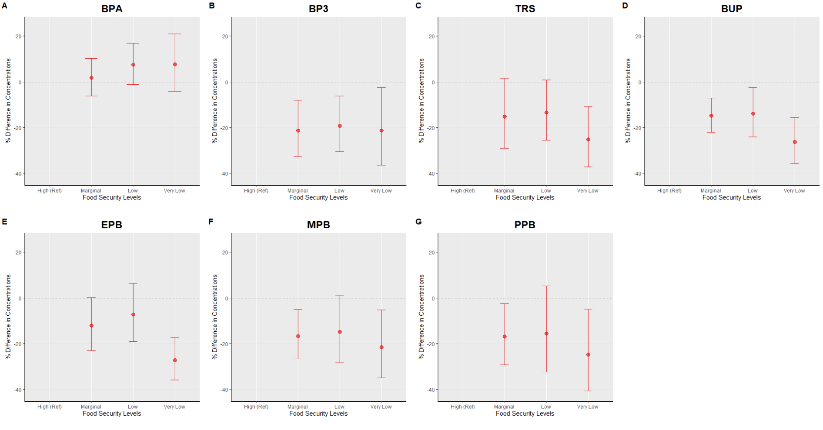
- Panels A–G represent adjusted percent differences in urinary phenol metabolite concentrations. Reference is High Food Secure. Circles represent estimated percent differences; bars represent 95% confidence intervals. All models are adjusted for age, sex education, race/ethnicity, poverty-income ratio, cycle year, and creatinine.

Multiple Linear Regression Models
One urinary phenol metabolite (BPA, BP3, TRS, EPB, MPB, and PPB) is shown in each panel, with the high food security group as the reference (Figure 1). After adjusting for sociodemographic variables, all urinary phenol concentrations besides BPA had higher differences in comparison to the reference group, showing that concentrations increased as food security categories reached lower status, reflecting an inverse association. Higher BPA concentrations were suggestively associated with low and very low food security groups. However, these associations did not have a statistical significance.

Figure 2: Strata Specific Adjusted Linear Regression Plot: Self-Reported Food Security Status and Urinary Phenol Metabolites with Sex Interaction

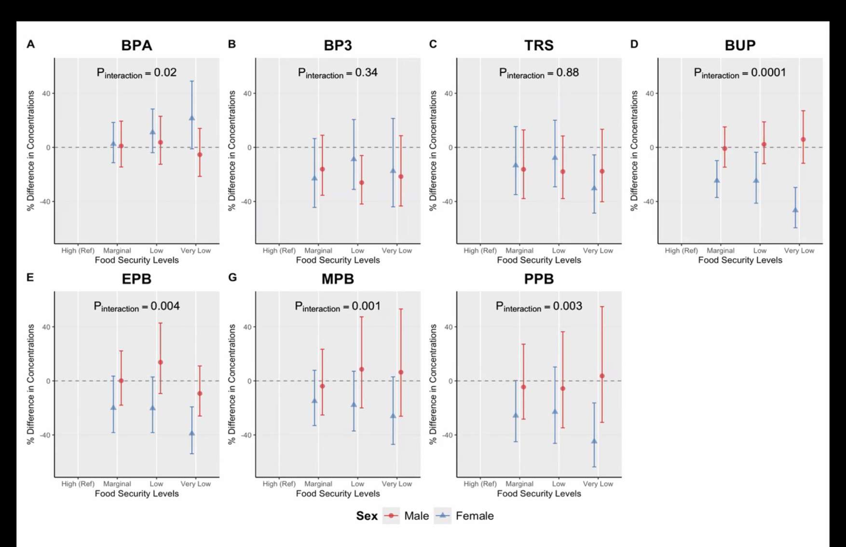

- Sex stratified adjusted percent differences (95% confidence intervals) in urinary phenol metabolite
- Concentrations across food security levels, estmated from multivariable linear regression models adjusted for age, race and ethnicity, education, survey cycle, poverty:income ratio and creatinine. High Food Secure is the reference group.
- P_{interaction} values are reported from food security*sex interaction models, where food security is modeled as continuous variable.

Effect Measure Modification by Sex

For effect measure modification by sex, the BPA (pinteraction= 0.02) model revealed significant interactions as food security status decreased. Based on strata specific predicted marginal means, females experiencing low food security had higher BPA concentrations (11.08%; 95% CI: -3.9%, 28.41%, Figure 2, Supplemental Table 2) compared to females with high food security (reference). Additionally, females experiencing very low food security had higher percent differences of BPA (21.45%; 95% CI: -1.04%, 49.05%) compared to females within the high food security group. Males did not reveal any significant differences besides BUP ($p_{interaction}$= 0.00). Males experiencing very low food security had higher percent differences compared to males in the high food security food category (5.93%; CI: -11.74%, 27.14%, Figure 2, Supplemental Table 2). Females did not show similar differences.

Figure 3: Strata-Specific Adjusted Linear Regression Plot: Self-Reported Food Security Status and Urinary Phenol Metabolites with Race and Ethnicity Interaction

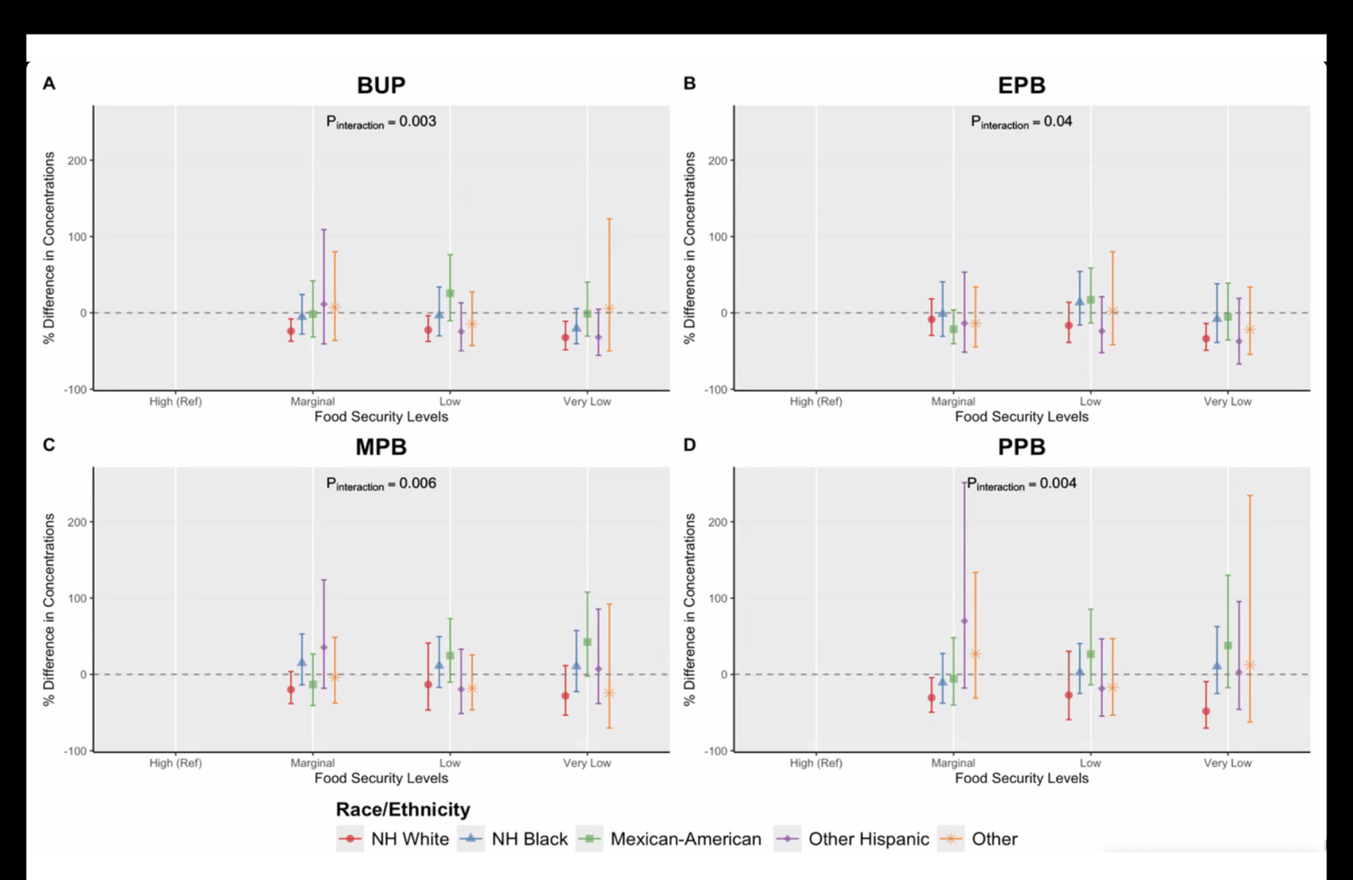

- Race stratified adjusted percent differences (95% confidence intervals) in urinary phenol metabolite concentrations across food security levels, estmated from multivariable linear regression models adjusted for age, sex, education, survey cycle, poverty:income ratio and creatinine. High Food Secure is the reference group.
- P_{interaction} values are reported from food security*race and ethnicity interaction models, where food security is modeled as continuous variable.
- NH White: Non Hispanic White; NH Black: Non-Hispanic Black

Effect Measure Modification by Race/Ethnicity

We analyzed the effect measure modification by race and ethnicity and observed several interactions between food security levels and phthalates (Supplemental Tables 3-9). Within strata specific predicted marginal means, higher percent differences of EPB (pinteraction= 0.04) concentrations were found in only Non-Hispanic Black adults (13.88%; CI: -15.89%, 54.18%, Figure 3, Supplemental Table 7) and Mexican American adults experiencing low food security (17.21%; CI: -13.39%, 58.63%, Figure 3, Supplemental Table 7) compared to those in these racial groups experiencing high food security. We observed higher MPB (pinteraction= 0.00) concentrations in Non-Hispanic Black (low food security: 11.32%; CI: -17.07%, 49.43%, Figure 3, Supplemental Table 8) and Mexican American (low food security: 24.69%; CI: -10.20%, 73.13%; very low security: 42.53%, CI: -2.18%, 107.69, Figure 3, Supplemental Table 8) adults compared to those high food secure adults. Furthermore, higher levels of PBB concentrations were also found in Mexican Americans within the low (26.54%; CI: -13.62%, 85.37%, Figure 3, Supplemental Table 9) and very low (37.84%, CI: -17.37%, 129.92%, Figure 3, Supplemental Table 9) food security categories in comparison to fully food secure adults across all other race and ethnic groups. For BPA concentration levels, only Non-Hispanic White (very low food security: 13.96%, CI: -11.85%, 47.32%, Figure 3, Supplemental Table 3) and other race individuals (very low food security: 6.41%; CI: -18.81%, 96.82%, Figure 3, Supplemental Table 3) had higher percent differences compared to high food secure individuals. Although BPA had similar trends to multiple phthalate metabolites, it was not statistically significant.

Supplemental Figure 1: Flowchart for NHANES Analytic Sample (2005-2016)
18,961 NHANES participants with available Phenols, food security and/or demographic data
Removed 5,754 participants who identified as children

13,207 Adult participants with (n=9 Phenols measured across relevant cycle years 2003-2016)

Removed 2,784 participants with missing creatinine, or exposure data

10,423 Adult participants with available creatinine and USDA FSSM questionnaire data

Edit: Removed 329 participants after excluding Bisphenol F and Bisphenol S from the urinary phenol list, participants missing urinary phenol concentration data, and the 2003–2004 cycle.

10,094 included in final analytic cohort (complete cases)

- Adult participants from the 2005–2016 NHANES cycles were included if demographic, food security, urinary Phenol, and urinary creatinine data were available. Participants were excluded for missing exposure values, missing urinary creatinine or urinary Phenol concentrations, and extreme outliers.
- Abbreviations: NHANES, National Health and Nutrition Examination Survey; FSSM, Food Security Survey Module; SD, standard deviation

Supplemental Figure 2: Spearman Correlation Matrix for Log Urinary Phenol Metabolites

- Spearman correlation coefficients are visualized, with larger and darker circles indicating stronger positive correlations between analytes. All correlations shown are positive, suggesting co-occurrence or shared sources among the measured phenol metabolites and related compounds.

Supplemental Figure 3: Strata-Specific Adjusted Linear Regression Plot: Self-Reported Food Security Status and Urinary Phenol Metabolites with Race and Ethnicity Interaction

- Race stratified adjusted percent differences (95% confidence intervals) in urinary phenol metabolite concentrations across food security levels, estmated from multivariable linear regression models adjusted for age, sex, education, survey cycle, poverty:income ratio and creatinine. High Food Secure is the reference group.
- P_{interaction} values are reported from food security*race and ethnicity interaction models, where food security is modeled as continuous variable.
- NH White: Non Hispanic White; NH Black: Non-Hispanic Black

Supplemental Table 1: Creatinine Adjusted: Self-Reported Food Security Status
O  Phenol Metabolite del | Term | Food Security Level | % Difference | 95% CI |  | P-Value
BPA | Intercept (Ref)  Marginal Food Secure  Low Food Secure  Very Low Food Secure | 1
BPA |  | 2 | 1.36 | -11.93 | 16.66 | 0.85
BPA |  | 3 | -9.85 | -19.51 | 0.97 | 0.07
BPA |  | 4 | -7.25 | -20.00 | 7.53 | 0.32
BP3 | Intercept (Ref)  Marginal Food Secure  Low Food Secure  Very Low Food Secure | 1
BP3 |  | 2 | -5.08 | -12.02 | 2.41 | 0.18
BP3 |  | 3 | -2.70 | -9.25 | 4.32 | 0.44
BP3 |  | 4 | 10.42 | -0.79 | 22.89 | 0.07
TRS | Intercept (Ref)  Marginal Food Secure  Low Food Secure  Very Low Food Secure | 1
TRS |  | 2 | 23.17 | 10.38 | 37.43 | 0.00
TRS |  | 3 | 18.18 | 7.75 | 29.61 | 0.00
TRS |  | 4 | 27.84 | 15.56 | 41.41 | 0.00
BUP | Intercept (Ref)  Marginal Food Secure  Low Food Secure  Very Low Food Secure | 1
BUP |  | 2 | 6.28 | -2.30 | 15.60 | 0.15
BUP |  | 3 | 11.59 | 0.93 | 23.38 | 0.03
BUP |  | 4 | 33.66 | 14.57 | 55.92 | 0.00
EPB | Intercept (Ref)  Marginal Food Secure  Low Food Secure  Very Low Food Secure | 1
EPB |  | 2 | -9.56 | -16.70 | -1.82 | 0.02
EPB |  | 3 | -17.65 | -24.29 | -10.43 | 0.00
EPB |  | 4 | -9.17 | -19.26 | 2.18 | 0.11
MPB | Intercept (Ref)  Marginal Food Secure  Low Food Secure  Very Low Food Secure | 1
MPB |  | 2 | 1.61 | -10.47 | 15.31 | 0.80
MPB |  | 3 | -6.53 | -15.22 | 3.05 | 0.17
MPB |  | 4 | -1.07 | -12.16 | 11.42 | 0.86
PPB | Intercept (Ref)  Marginal Food Secure  Low Food Secure | 1
PPB |  | 2 | 2.86 | -3.72 | 9.89 | 0.40
PPB |  | 3 | 6.08 | 0.09 | 12.43 | 0.05
PPB |  |  | 20.60 | 9.99 | 32.23 | 0.00
PPB | Very Low Food Secure | 4
- Values are unadjusted percent differences in urinary phenol metabolite concentrations (ng/mL) compared to the reference group (High (Ref)y Food Secure) based on multivariable linear regression models.
- 95% CI= 95% confidence interval.

Supplemental Table 2: Strata Specific Adjusted Linear Regression Full Table: Self-Reported Food Security Status and Urinary Phenol Metabolites with Sex Interaction
Sex | Phenol Metabolite | Food Security Level | % Difference (Interaction) | 95% CI
Male | BPA | High (Ref)
 |  | Marginal | 1.08 | -14.46 | 19.43
 |  | Low | 3.76 | -12.46 | 22.99
 |  | Very Low | -5.35 | -21.46 | 14.06
Female |  | High (Ref)
 |  | Marginal | 2.5 | -11.32 | 18.47
 |  | Low | 11.08 | -3.9 | 28.41
 |  | Very Low | 21.45 | -1.04 | 49.05
Male | BP3 | High (Ref)
 |  | Marginal | -16.08 | -35.4 | 9.02
 |  | Low | -26.04 | -41.81 | -5.99
 |  | Very Low | -21.55 | -43.36 | 8.66
Female |  | High (Ref)
 |  | Marginal | -23.03 | -44.39 | 6.54
 |  | Low | -8.78 | -31 | 20.6
 |  | Very Low | -17.51 | -43.95 | 21.41
Male | TRS | High (Ref)
 |  | Marginal | -16.23 | -37.84 | 12.91
 |  | Low | -17.87 | -37.81 | 8.47
 |  | Very Low | -17.63 | -40.19 | 13.44
Female |  | High (Ref)
 |  | Marginal | -13.31 | -34.9 | 15.43
 |  | Low | -7.74 | -29.12 | 20.09
 |  | Very Low | -30.31 | -48.6 | -5.52
Male | BUP | High (Ref)
 |  | Marginal | -0.83 | -14.6 | 15.17
 |  | Low | 2.28 | -12.01 | 18.89
 |  | Very Low | 5.93 | -11.74 | 27.14
Female |  | High (Ref)
 |  | Marginal | -24.64 | -37.05 | -9.77
 |  | Low | -24.73 | -41.24 | -3.58
 |  | Very Low | -46.55 | -59.43 | -29.59
Male | $$EPB$$ | High (Ref)
 |  | Marginal | 0.12 | -17.97 | 22.2
 |  | Low | 13.78 | -9.33 | 42.78
 |  | Very Low | -9.31 | -25.94 | 11.07
Female |  | High (Ref)
 |  | Marginal | -20.04 | -38.24 | 3.51
 |  | Low | -20.29 | -38.25 | 2.89
 |  | Very Low | -38.94 | -53.86 | -19.21
Female | $$MPB$$ | High (Ref)
 |  | Marginal | -3.93 | -25.21 | 23.42
 |  | Low | 8.59 | -19.99 | 47.37
 |  | Very Low | 6.41 | -26.1 | 53.22
Male |  | High (Ref)
 |  | Marginal | -14.99 | -33.01 | 7.87
 |  | Low | -17.85 | -37.03 | 7.18
 |  | Very Low | -26.1 | -46.97 | 2.98
Female | $$PPB$$ | High (Ref)
 |  | Marginal | -4.53 | -28.3 | 27.13
 |  | Low | -5.65 | -34.7 | 36.34
 |  | Very Low | 3.64 | -30.68 | 54.94
Male |  | High (Ref)
 |  | Marginal | -25.71 | -44.96 | 0.27
 |  | Low | -22.96 | -46.2 | 10.31
 |  | Very Low | -44.82 | -63.63 | -16.28

Supplemental Table 3: Strata Specific Adjusted Linear Regression Full Table: Self-Reported Food Security Status and Urinary Bisphenol A Phenol Metabolites with Race and Ethnicity Interaction

Race/Ethnicity Category | Model | Food Security Contrast | % Difference | % Lower | % Upper | P-Value
NH White | BPA | High (Ref)
 |  | Marginal | 7.19 | -9.91 | 27.53 | 0.72
 |  | Low | 9.41 | -8.42 | 30.71 | 0.54
 |  | Very Low | 13.96 | -11.85 | 47.32 | 0.54
NH Black |  | High (Ref)
 |  | Marginal | -5.26 | -18.24 | 9.77 | 0.77
 |  | Low | 1.08 | -13.76 | 18.47 | 1.00
 |  | Very Low | -0.25 | -15.08 | 17.17 | 1.00
Mexican-American |  | High (Ref)
 |  | Marginal | -4.11 | -22.52 | 18.67 | 0.95
 |  | Low | 0.14 | -14.43 | 17.20 | 1.00
 |  | Very Low | -11.54 | -37.31 | 24.84 | 0.78
Other Hispanic |  | High (Ref)
 |  | Marginal | -5.61 | -28.16 | 24.01 | 0.94
 |  | Low | -5.23 | -24.30 | 18.65 | 0.92
 |  | Very Low | 2.56 | -31.39 | 53.32 | 1.00
Other |  | High (Ref)
 |  | Marginal | -6.79 | -31.10 | 26.10 | 0.93
 |  | Low | 36.95 | -16.26 | 123.98 | 0.34
 |  | Very Low | 26.41 | -18.81 | 96.82 | 0.50
- Values represent percent differences for Food Security Level × Race and Ethnicity interaction terms, showing strata-specific estimates. Within each race and ethnicity group (NH White, NH Black, Mexican American, Other Hispanic, Other, ) estimates indicate the percent difference for each food security level compared with the reference. Estimates are derived from multivariable linear regression models adjusted for age, sex, education, cycle year, poverty: income ratio and creatinine.
- NH White: Non Hispanic White; NH Black: Non-Hispanic Black
- 95% CI = 95% confidence interval

Supplemental Table 4: Strata Specific Adjusted Linear Regression Full Table: Self-Reported Food Security Status and Urinary Benzophenone-3 Phenol Metabolites with Race and Ethnicity Interaction

Race/Ethnicity Category | Model | Food Security Contrast | % Difference | % Lower | % Upper | P-Value
NH White | BP3 | High (Ref)
 |  | Marginal | -28.70 | -48.72 | -0.87 | 0.04
 |  | Low | -27.92 | -48.98 | 1.84 | 0.07
 |  | Very Low | -33.44 | -58.81 | 7.56 | 0.12
NH Black |  | High (Ref)
 |  | Marginal | -15.93 | -41.65 | 21.12 | 0.59
 |  | Low | -2.98 | -31.62 | 37.65 | 1.00
 |  | Very Low | 11.06 | -27.60 | 70.36 | 0.92
Mexican-American |  | High (Ref)
 |  | Marginal | -2.94 | -36.16 | 47.57 | 1.00
 |  | Low | 1.00 | -27.35 | 40.41 | 1.00
 |  | Very Low | 3.52 | -38.55 | 74.39 | 1.00
Other Hispanic |  | High (Ref)
 |  | Marginal | 45.85 | -24.66 | 182.35 | 0.44
 |  | Low | 2.52 | -37.93 | 69.31 | 1.00
 |  | Very Low | -9.51 | -53.73 | 76.98 | 0.98
Other |  | High (Ref)
 |  | Marginal | -33.54 | -59.54 | 9.16 | 0.14
 |  | Low | -21.54 | -54.22 | 34.48 | 0.64
 |  | Very Low | -5.03 | -56.58 | 107.74 | 1.00
- Values represent percent differences for Food Security Level × Race and Ethnicity interaction terms, showing strata-specific estimates. Within each race and ethnicity group (NH White, NH Black, Mexican American, Other Hispanic, Other, ) estimates indicate the percent difference for each food security level compared with the reference. Estimates are derived from multivariable linear regression models adjusted for age, sex, education, cycle year, poverty: income ratio and creatinine.
- NH White: Non Hispanic White; NH Black: Non-Hispanic Black
- 95% CI = 95% confidence interval

Supplemental Table 5: Strata Specific Adjusted Linear Regression Full Table: Self-Reported Food Security Status and Urinary Triclosan Phenol Metabolites with Race and Ethnicity Interaction

Race/Ethnicity Category | Model | Food Security Contrast | % Difference | % Lower | % Upper | P-Value
NH White | TRS | High (Ref)
 |  | Marginal | -19.32 | -44.37 | 17.01 | 0.43
 |  | Low | -21.28 | -42.74 | 8.23 | 0.20
 |  | Very Low | -27.72 | -49.16 | 2.77 | 0.08
NH Black |  | High (Ref)
 |  | Marginal | 3.33 | -31.26 | 55.33 | 1.00
 |  | Low | -4.87 | -31.91 | 32.92 | 0.98
 |  | Very Low | -8.95 | -38.66 | 35.15 | 0.92
Mexican-American |  | High (Ref)
 |  | Marginal | -10.47 | -41.78 | 37.67 | 0.90
 |  | Low | 8.20 | -34.34 | 78.30 | 0.98
 |  | Very Low | -0.75 | -47.93 | 89.18 | 1.00
Other Hispanic |  | High (Ref)
 |  | Marginal | -12.86 | -57.72 | 79.59 | 0.96
 |  | Low | 8.17 | -50.51 | 136.40 | 0.99
 |  | Very Low | -25.50 | -58.93 | 35.15 | 0.56
Other |  | High (Ref)
 |  | Marginal | -15.42 | -55.96 | 62.43 | 0.90
 |  | Low | -28.70 | -61.22 | 31.08 | 0.46
 |  | Very Low | -60.86 | -83.14 | -9.11 | 0.02
- Values represent percent differences for Food Security Level × Race and Ethnicity interaction terms, showing strata-specific estimates. Within each race and ethnicity group (NH White, NH Black, Mexican American, Other Hispanic, Other, ) estimates indicate the percent difference for each food security level compared with the reference. Estimates are derived from multivariable linear regression models adjusted for age, sex, education, cycle year, poverty: income ratio and creatinine.
- NH White: Non Hispanic White; NH Black: Non-Hispanic Black
- 95% CI = 95% confidence interval

Supplemental Table 6: Strata Specific Adjusted Linear Regression Full Table: Self-Reported Food Security Status and Urinary Butyl Paraben Metabolites with Race and Ethnicity Interaction

Race/Ethnicity Category | Model | Food Security Contrast | % Difference | % Lower | % Upper | P-Value
NH White | BUP | High (Ref)
 |  | Marginal | -23.95 | -37.16 | -7.96 | 0.00
 |  | Low | -22.47 | -37.52 | -3.79 | 0.01
 |  | Very Low | -32.29 | -48.42 | -11.10 | 0.00
NH Black |  | High (Ref)
 |  | Marginal | -5.33 | -27.71 | 23.98 | 0.95
 |  | Low | -3.31 | -30.20 | 33.93 | 0.99
 |  | Very Low | -20.74 | -40.46 | 5.51 | 0.15
Mexican-American |  | High (Ref)
 |  | Marginal | -1.61 | -31.75 | 41.85 | 1.00
 |  | Low | 25.63 | -10.42 | 76.19 | 0.29
 |  | Very Low | -1.23 | -30.43 | 40.24 | 1.00
Other Hispanic |  | High (Ref)
 |  | Marginal | 11.36 | -40.68 | 109.06 | 0.97
 |  | Low | -24.56 | -49.68 | 13.09 | 0.26
 |  | Very Low | -31.89 | -55.71 | 4.73 | 0.10
Other |  | High (Ref)
 |  | Marginal | 7.27 | -36.14 | 80.19 | 0.98
 |  | Low | -14.83 | -42.98 | 27.20 | 0.72
 |  | Very Low | 5.63 | -49.97 | 123.05 | 1.00
- Values represent percent differences for Food Security Level × Race and Ethnicity interaction terms, showing strata-specific estimates. Within each race and ethnicity group (NH White, NH Black, Mexican American, Other Hispanic, Other, ) estimates indicate the percent difference for each food security level compared with the reference. Estimates are derived from multivariable linear regression models adjusted for age, sex, education, cycle year, poverty: income ratio and creatinine.
- NH White: Non Hispanic White; NH Black: Non-Hispanic Black
- 95% CI = 95% confidence interval

Supplemental Table 7: Strata Specific Adjusted Linear Regression Full Table: Self-Reported Food Security Status and Urinary Ethyl Phenol Metabolites with Race and Ethnicity Interaction

Race/Ethnicity Category | Model | Food Security Contrast | % Difference | % Lower | % Upper | P-Value
NH White | EPB | High (Ref)
 |  | Marginal | -8.68 | -29.52 | 18.34 | 0.79
 |  | Low | -16.56 | -38.83 | 13.81 | 0.42
 |  | Very Low | -33.81 | -49.12 | -13.90 | 0.00
NH Black |  | High (Ref)
 |  | Marginal | -1.33 | -30.77 | 40.62 | 1.00
 |  | Low | 13.88 | -15.89 | 54.18 | 0.67
 |  | Very Low | -8.10 | -38.85 | 38.11 | 0.95
Mexican-American |  | High (Ref)
 |  | Marginal | -21.44 | -40.49 | 3.71 | 0.11
 |  | Low | 17.21 | -13.39 | 58.63 | 0.51
 |  | Very Low | -5.39 | -35.55 | 38.87 | 0.98
Other Hispanic |  | High (Ref)
 |  | Marginal | -13.89 | -51.65 | 53.35 | 0.90
 |  | Low | -23.94 | -52.24 | 21.12 | 0.41
 |  | Very Low | -37.32 | -67.00 | 19.05 | 0.23
Other |  | High (Ref)
 |  | Marginal | -13.86 | -44.63 | 34.02 | 0.81
 |  | Low | 2.35 | -41.84 | 80.11 | 1.00
 |  | Very Low | -21.85 | -54.36 | 33.80 | 0.62
- Values represent percent differences for Food Security Level × Race and Ethnicity interaction terms, showing strata-specific estimates. Within each race and ethnicity group (NH White, NH Black, Mexican American, Other Hispanic, Other, ) estimates indicate the percent difference for each food security level compared with the reference. Estimates are derived from multivariable linear regression models adjusted for age, sex, education, cycle year, poverty: income ratio and creatinine.
- NH White: Non Hispanic White; NH Black: Non-Hispanic Black
- 95% CI = 95% confidence interval

Supplemental Table 8: Strata Specific Adjusted Linear Regression Full Table: Self-Reported Food Security Status and Urinary Methyl Paraben Metabolites with Race and Ethnicity Interaction

Race/Ethnicity Category | Model | Food Security Contrast | % Difference | % Lower | % Upper | P-Value
NH White | MPB | High (Ref)
 |  | Marginal | -19.89 | -38.16 | 3.77 | 0.12
 |  | Low | -13.26 | -46.67 | 41.08 | 0.87
 |  | Very Low | -27.98 | -53.43 | 11.37 | 0.20
NH Black |  | High (Ref)
 |  | Marginal | 14.92 | -13.72 | 53.06 | 0.58
 |  | Low | 11.32 | -17.07 | 49.43 | 0.77
 |  | Very Low | 10.52 | -22.45 | 57.50 | 0.88
Mexican-American |  | High (Ref)
 |  | Marginal | -13.25 | -40.63 | 26.75 | 0.75
 |  | Low | 24.69 | -10.20 | 73.13 | 0.29
 |  | Very Low | 42.53 | -2.18 | 107.69 | 0.07
Other Hispanic |  | High (Ref)
 |  | Marginal | 35.32 | -18.18 | 123.81 | 0.39
 |  | Low | -19.58 | -51.35 | 32.94 | 0.66
 |  | Very Low | 7.16 | -38.14 | 85.64 | 0.99
Other |  | High (Ref)
 |  | Marginal | -3.62 | -37.52 | 48.67 | 1.00
 |  | Low | -18.07 | -46.61 | 25.72 | 0.61
 |  | Very Low | -24.38 | -70.22 | 92.06 | 0.86
- Values represent percent differences for Food Security Level × Race and Ethnicity interaction terms, showing strata-specific estimates. Within each race and ethnicity group (NH White, NH Black, Mexican American, Other Hispanic, Other, ) estimates indicate the percent difference for each food security level compared with the reference. Estimates are derived from multivariable linear regression models adjusted for age, sex, education, cycle year, poverty: income ratio and creatinine.
- NH White: Non Hispanic White; NH Black: Non-Hispanic Black
- 95% CI = 95% confidence interval

Supplemental Table 9: Strata Specific Adjusted Linear Regression Full Table: Self-Reported Food Security Status and Urinary Propyl Phenol Metabolites with Race and Ethnicity Interaction

Race/Ethnicity Category | Model | Food Security Contrast | % Difference | % Lower | % Upper | P-Value
NH White | PPB | High (Ref)
 |  | Marginal | -30.53 | -49.58 | -4.29 | 0.02
 |  | Low | -27.15 | -59.22 | 30.15 | 0.48
 |  | Very Low | -48.19 | -70.35 | -9.46 | 0.01
NH Black |  | High (Ref)
 |  | Marginal | -10.84 | -37.63 | 27.46 | 0.83
 |  | Low | 2.65 | -24.99 | 40.49 | 1.00
 |  | Very Low | 10.44 | -25.02 | 62.69 | 0.90
Mexican-American |  | High (Ref)
 |  | Marginal | -5.81 | -40.05 | 47.98 | 0.99
 |  | Low | 26.54 | -13.62 | 85.37 | 0.37
 |  | Very Low | 37.84 | -17.37 | 129.92 | 0.35
Other Hispanic |  | High (Ref)
 |  | Marginal | 69.95 | -17.84 | 251.52 | 0.23
 |  | Low | -18.43 | -54.59 | 46.52 | 0.79
 |  | Very Low | 2.87 | -45.88 | 95.53 | 1.00
Other |  | High (Ref)
 |  | Marginal | 27.03 | -30.96 | 133.74 | 0.73
 |  | Low | -17.21 | -53.35 | 46.92 | 0.82
 |  | Very Low | 12.13 | -62.41 | 234.42 | 0.99
- Values represent percent differences for Food Security Level × Race and Ethnicity interaction terms, showing strata-specific estimates. Within each race and ethnicity group (NH White, NH Black, Mexican American, Other Hispanic, Other, ) estimates indicate the percent difference for each food security level compared with the reference. Estimates are derived from multivariable linear regression models adjusted for age, sex, education, cycle year, poverty: income ratio and creatinine.
- NH White: Non Hispanic White; NH Black: Non-Hispanic Black
- 95% CI = 95% confidence interval

